Padding

Padding plays a crucial role in building the convolutional neural network. If the image will get shrink and if we will take a neural network with 100's of layers on it, it will give us a small image after filtered in the end.

If we take a three-by-three filter on top of a grayscale image and do the convolving then what will happen?

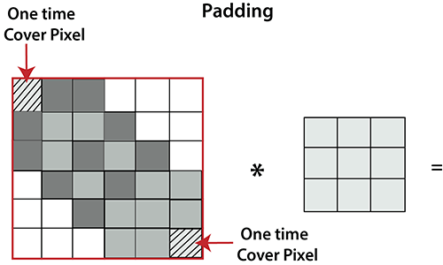

It is clear from the above picture that the pixel in the corner will only get covers one time, but the middle pixel will get covered more than once. It means that we have more information on that middle pixel, so there are two downsides:

* Shrinking outputs
* Losing information on the corner of the image.

To overcome this, we have introduced padding to an image. **"Padding is an additional layer which can add to the border of an image."**

## Pooling Layer

Pooling layer plays an important role in pre-processing of an image. Pooling layer reduces the number of parameters when the images are too large. Pooling is "**downscaling**" of the image obtained from the previous layers. It can be compared to shrinking an image to reduce its pixel density. Spatial pooling is also called downsampling or subsampling, which reduces the dimensionality of each map but retains the important information. There are the following types of spatial pooling:

### **Max Pooling**

Max pooling is a **sample-based discretization process**. Its main objective is to downscale an input representation, reducing its dimensionality and allowing for the assumption to be made about features contained in the sub-region binned.

Max pooling is done by applying a max filter to non-overlapping sub-regions of the initial representation.

